5.7

Always rememeber **Action of form and route should be same** no matter what.

For loading the bootstrap

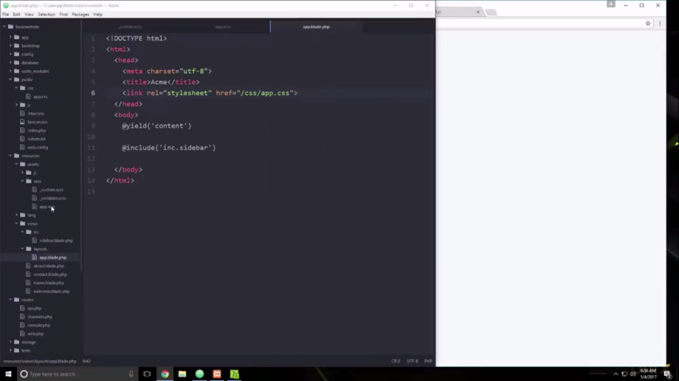

**Making the controller from cmd**

php artisan make:controller PostController --resource

**Making the Model**

php artisan make: model User -m

php artisan route:list

If the view file is inside the folder

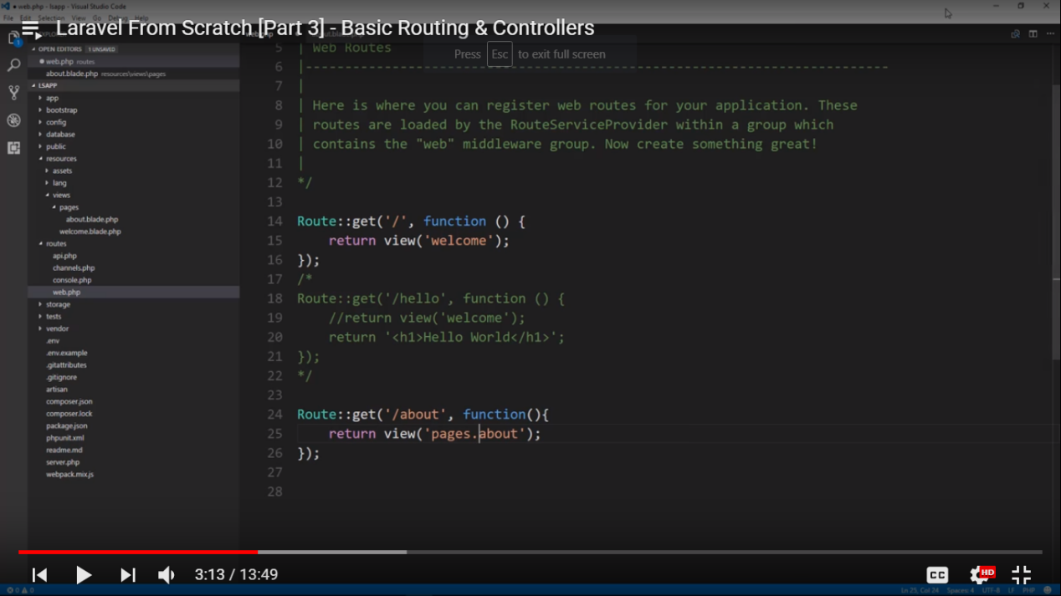

We could use pages/about or pages.about under pages folder we have about view

Now we are adding dynamic values in url

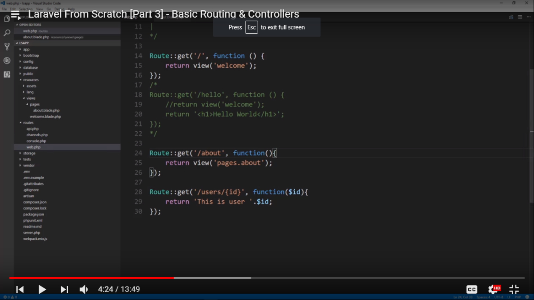

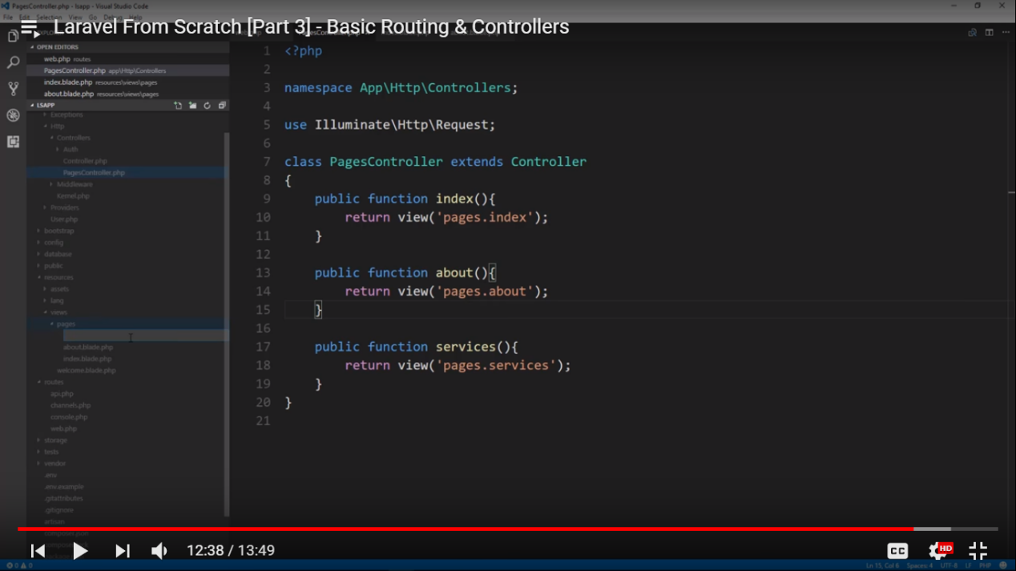

///

Passing values to the view

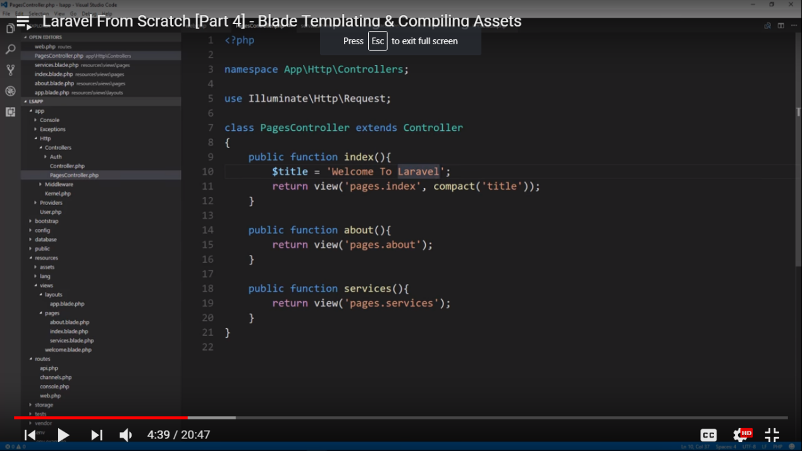

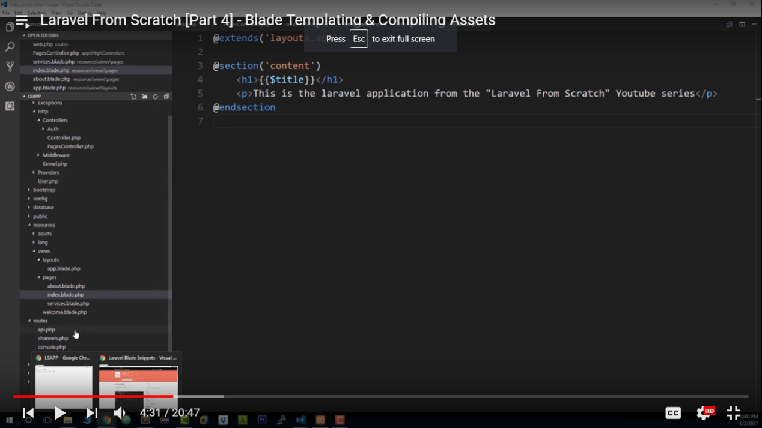

Or

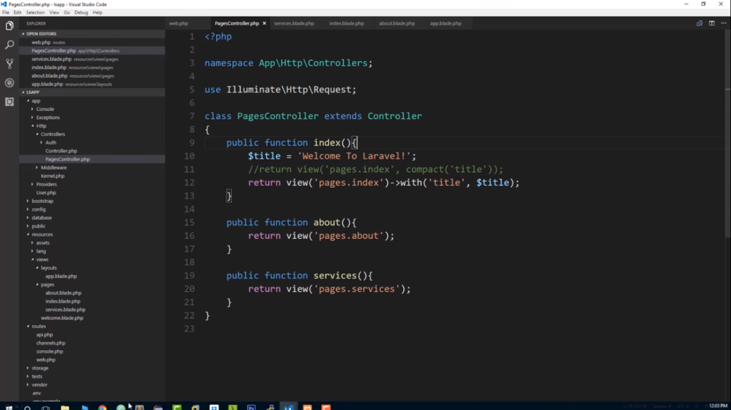

We can also chnage our view file as

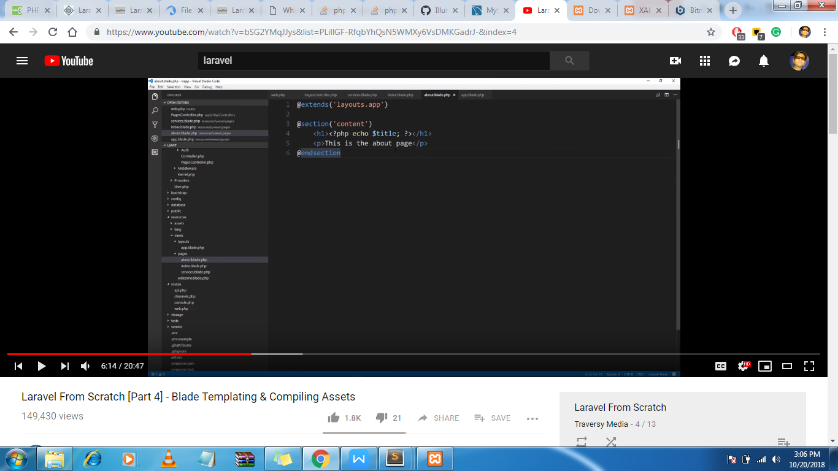

///

We can also pass an array to the views

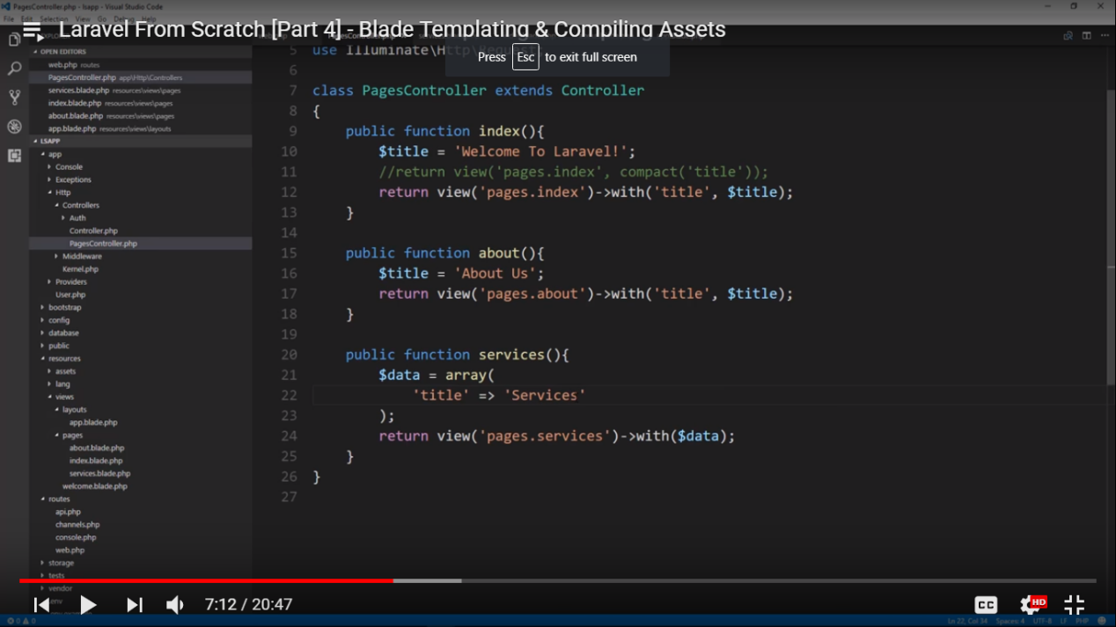

//////

Passing an array containing an another array. In a view

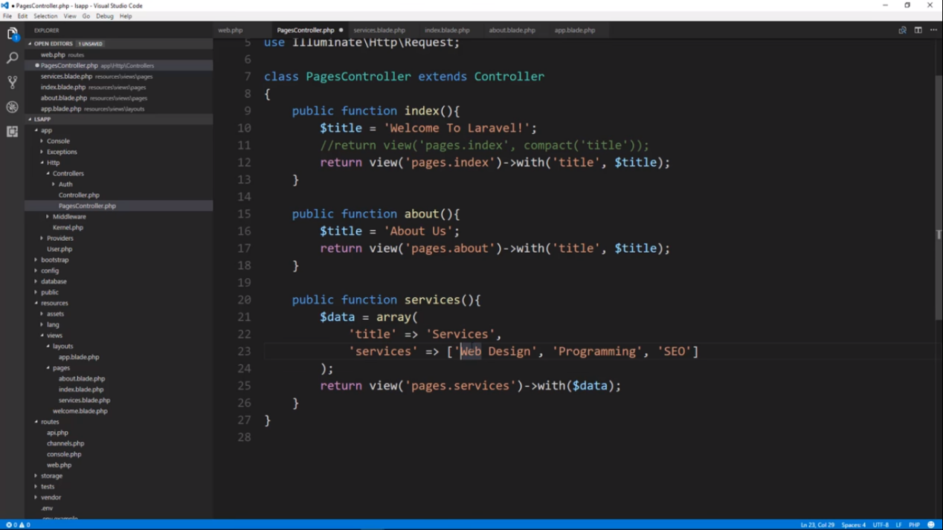

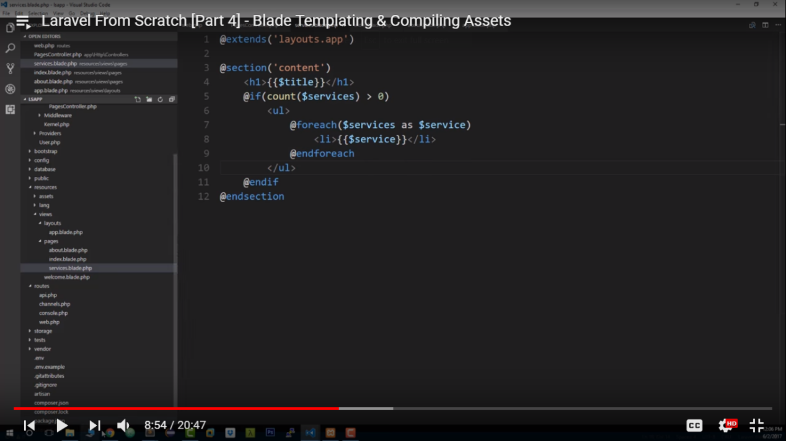

**Tutorial 4 -- conatins Blade templating and compiling assets**

**Tutorial 5**

Here we have to show all the routes

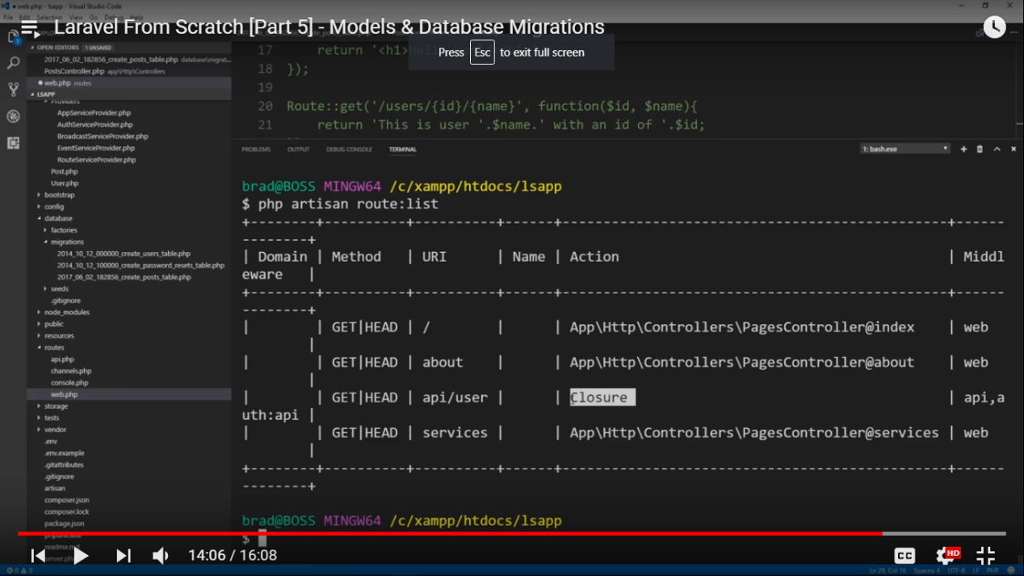

Now if we use below command then it will automatically make the routes

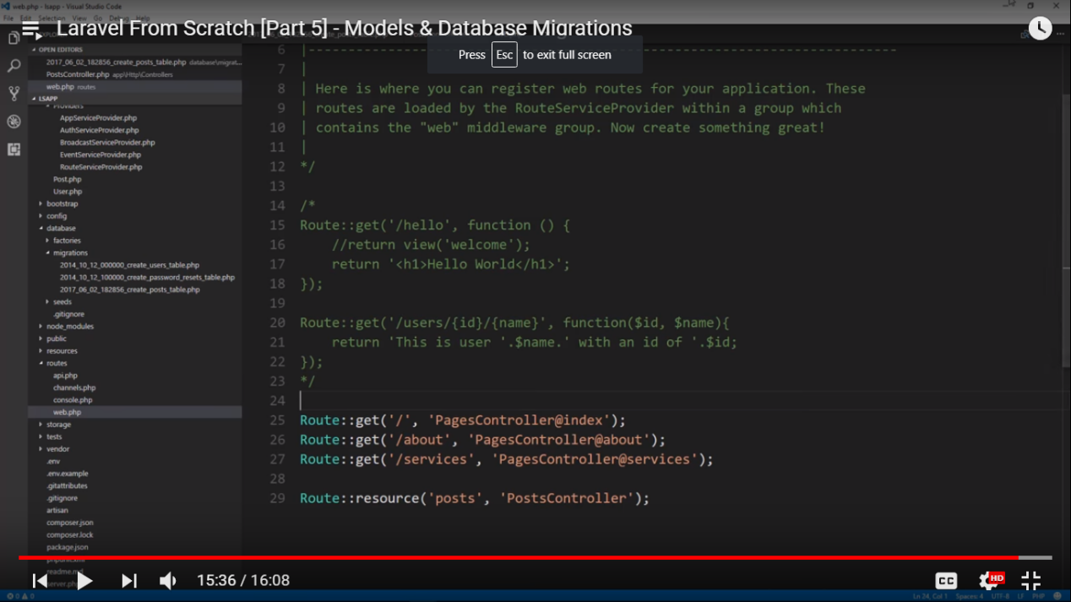

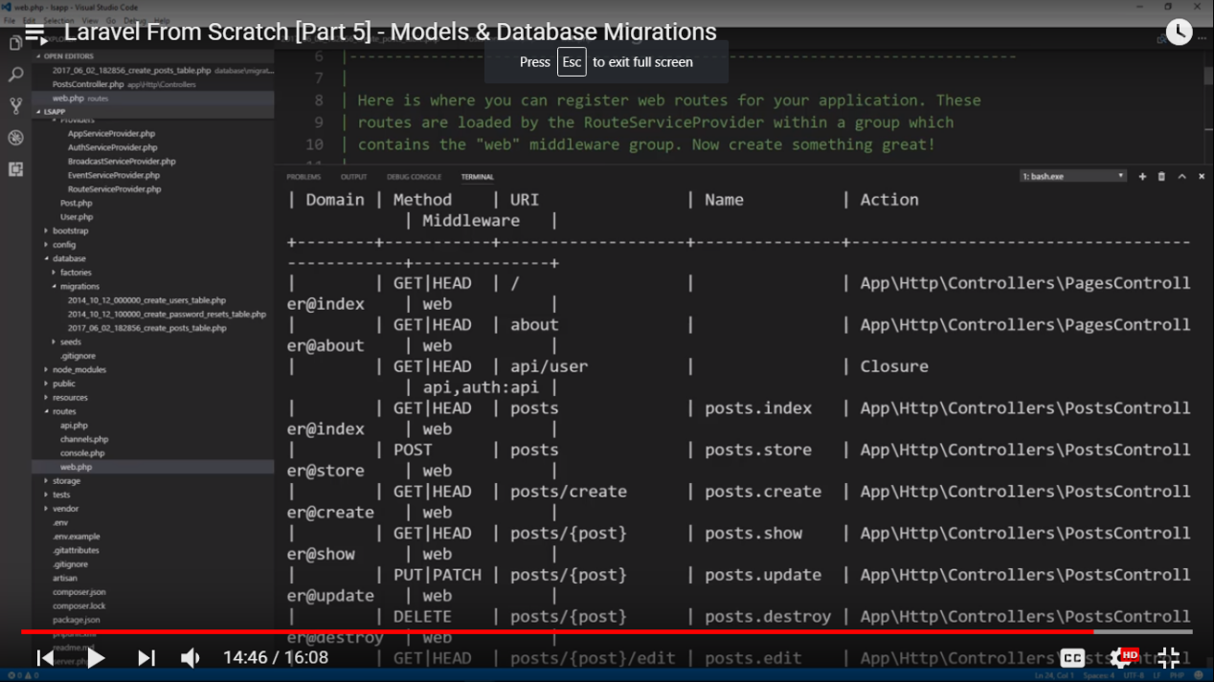

If we use **php artisan make:controller PostController --resource**

Then it will automatically make the method inside the controller

///

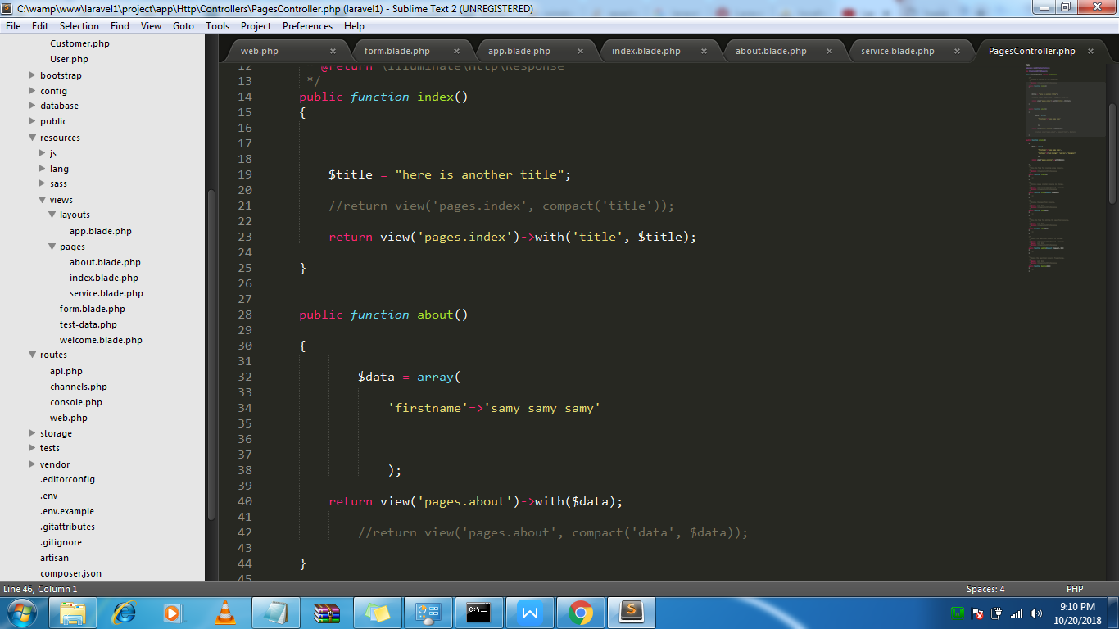

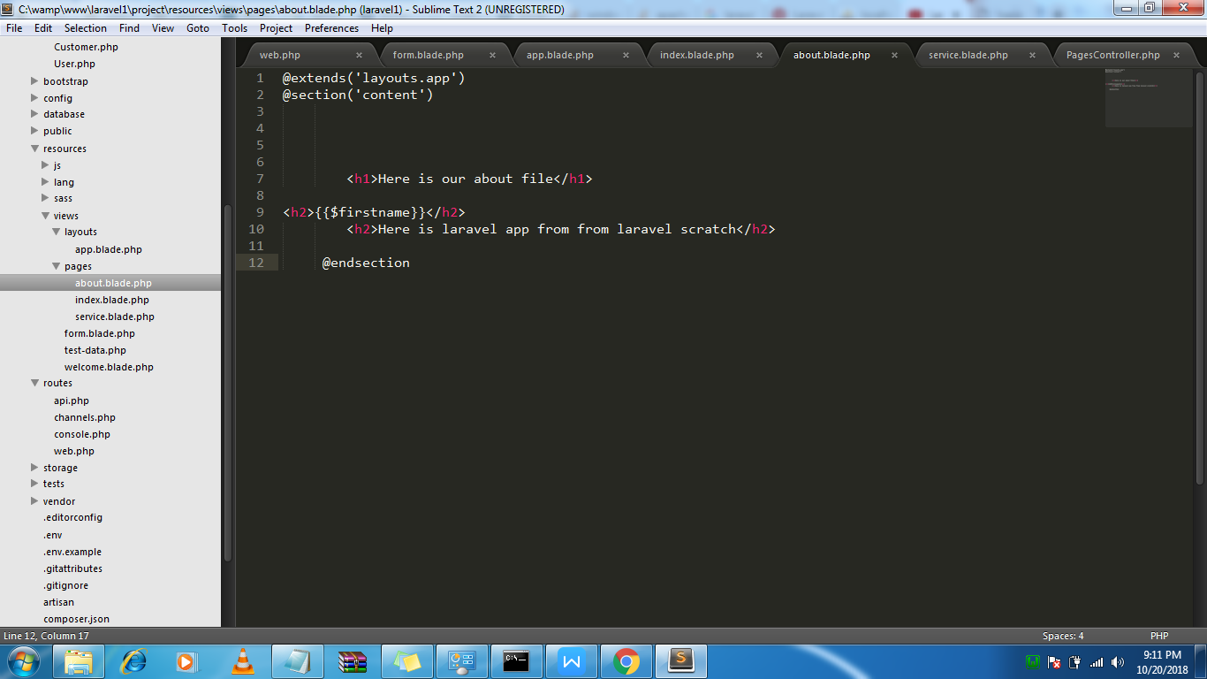

///

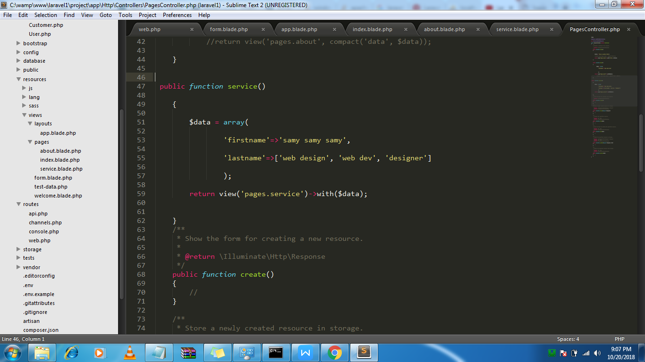

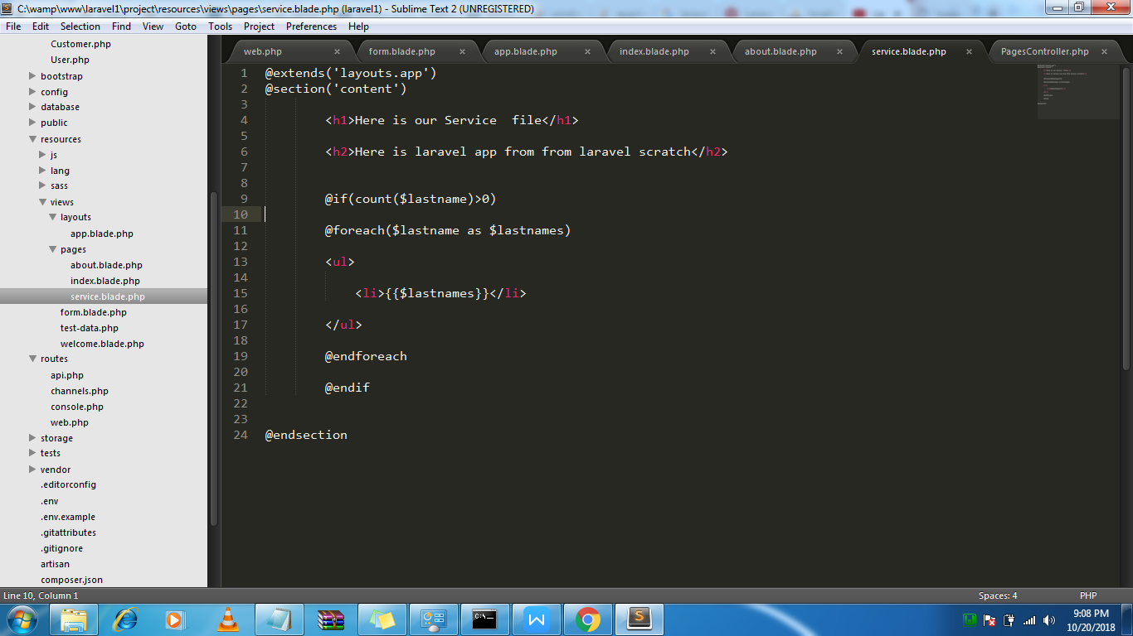

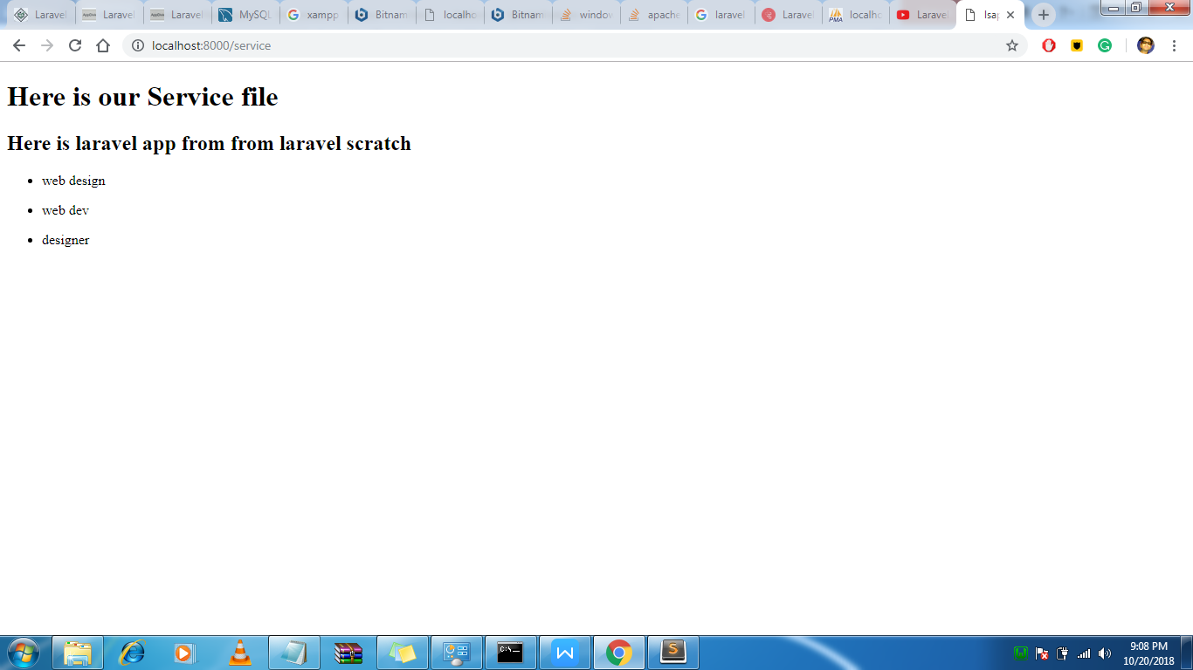

Public is a compiled folder do not chnage that

For loading css files in our project

We will load from the public assets folder

<link rel="stylesheet" href="{{asset('css/app.css')}}">

If u want to chnage then under resources change the files (for css)

**Tutorial 5**

For migration we will make singular model like Post, User **not** Posts, Users because it create tables in plural form like Posts, Users

From this table we can add more fields to the table

**Php artisan make:model Post -m**

To avoid max length issue we will go to the under providers .

**use Illuminate\Support\Facades\Schema;**

Schema::defaultStringLength(191);

If we don’t include then we will get some strange migartion errors

For migration just type the command

Php artisan migrate

..

To insert into db just use the tinker

Use the command php artisan tinker

App\Post::count()

$post = new App\Post();

$post->firstname = ‘sdff’;

From here we can interact with orm eloquent.

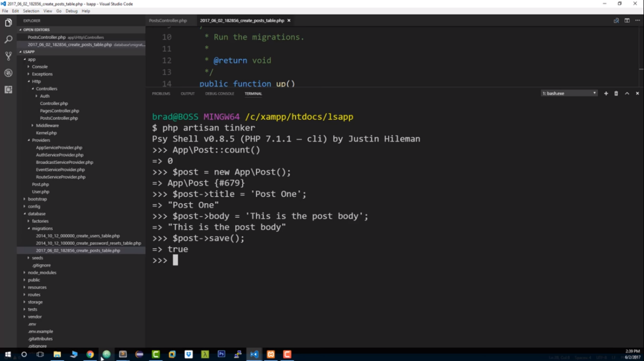

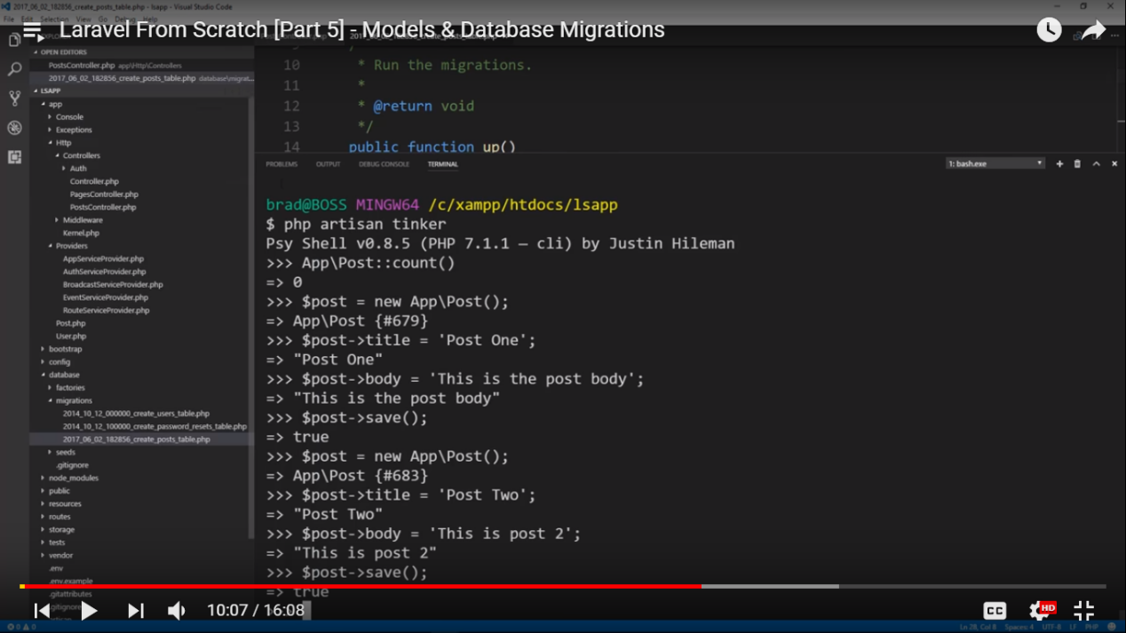

**Migration**

**Php artisan make:model Post -m**

**Always make model singlular like post. With -m**

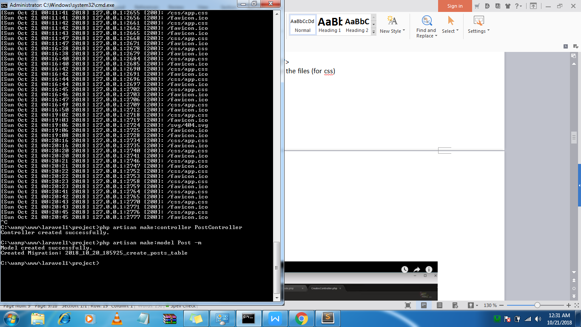

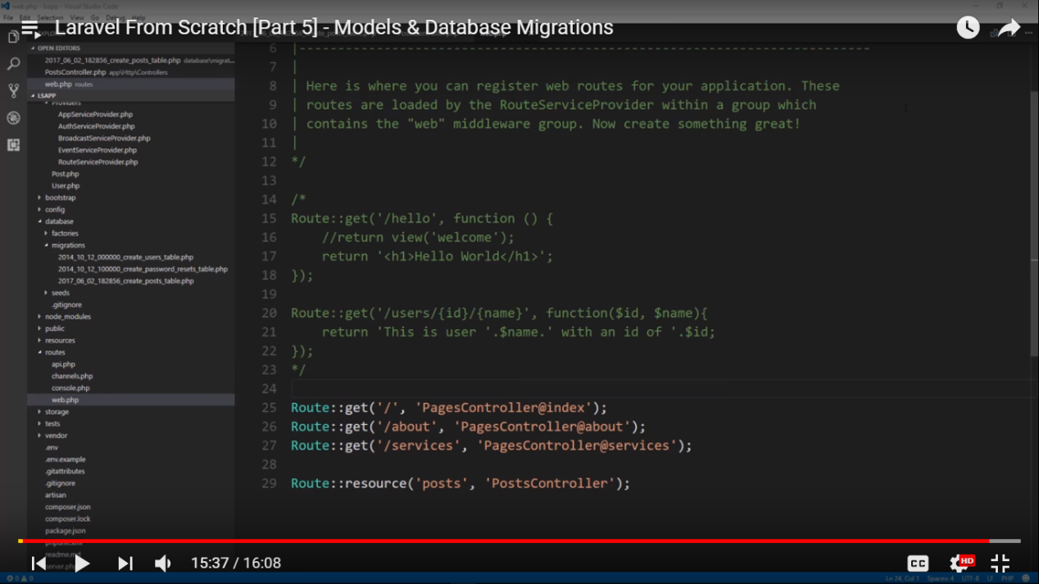

**Tuttorial 6**

**Using model for returning all the data from table**

Return Posts::all();

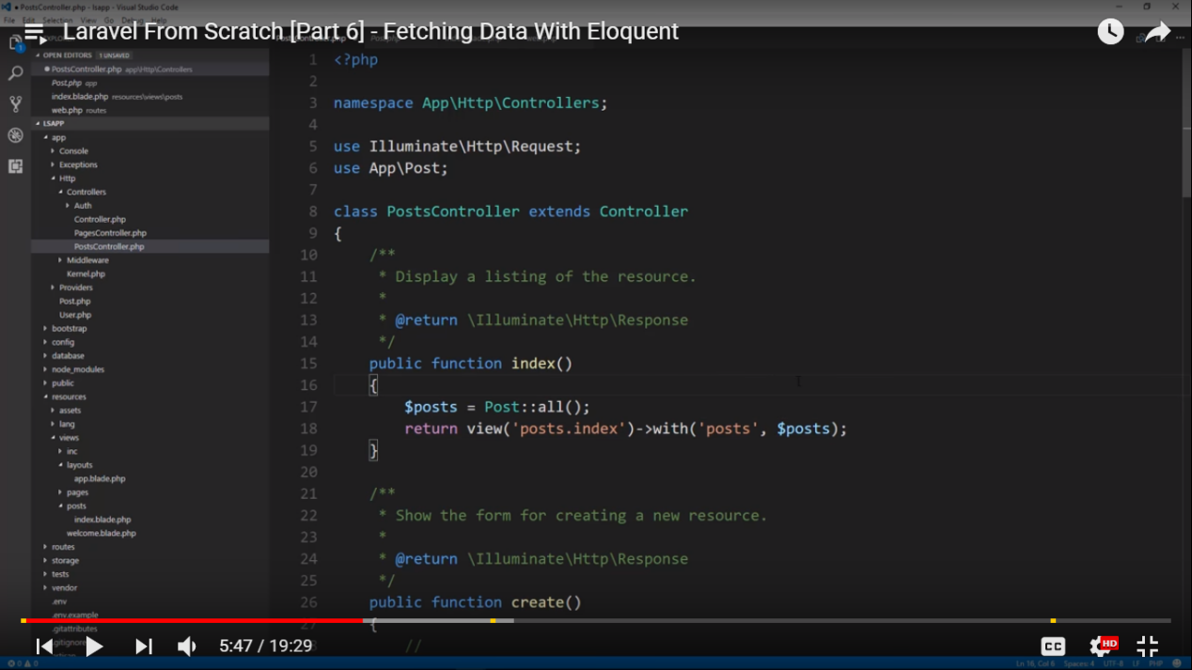

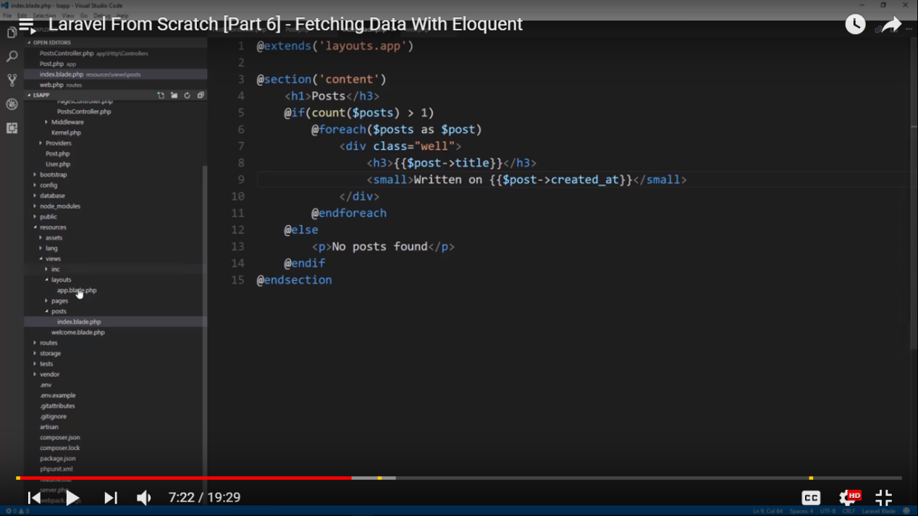

**1**

Employee::all();

It will show all data from the table

Or

$employee = new Employee;

Or

$data= $employee->all();

**2**

Employee::find($id);

Or

$employee= new Employee

$employee->find($id);

**3**

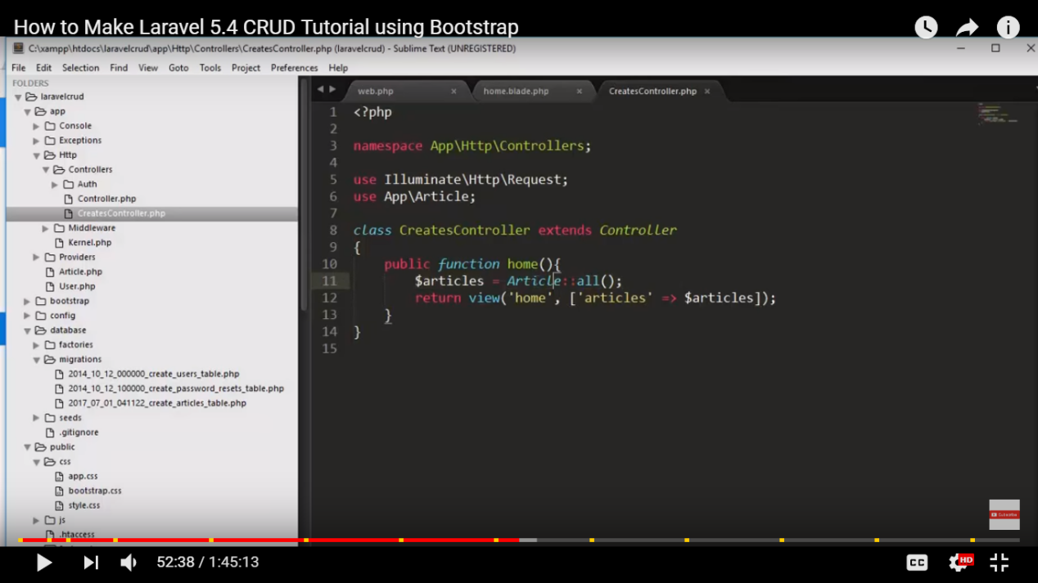

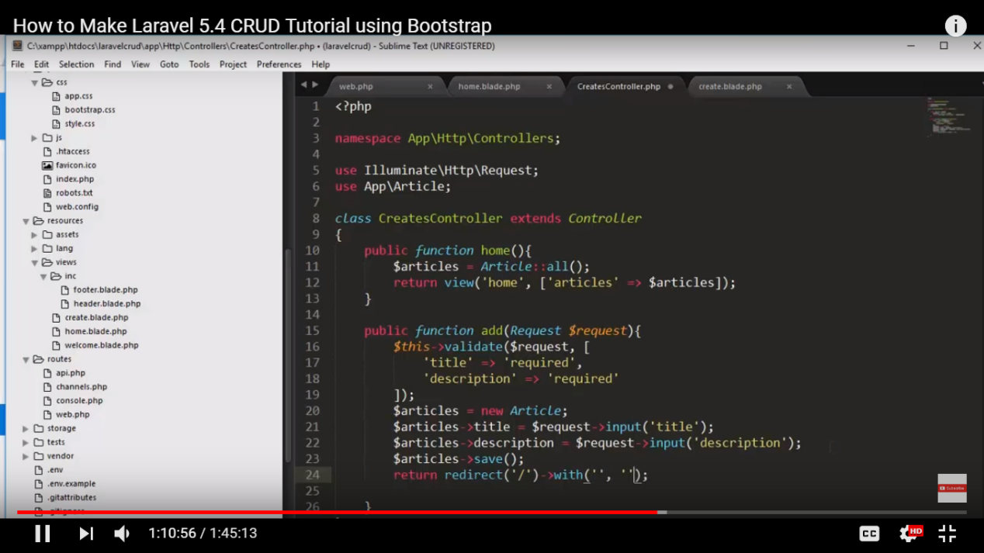

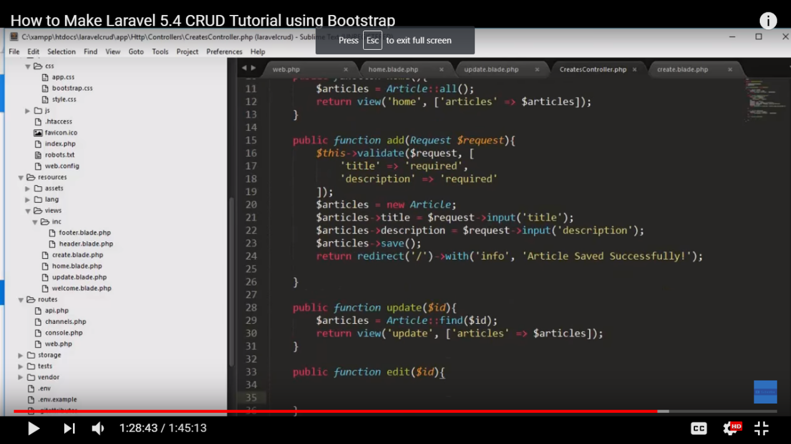

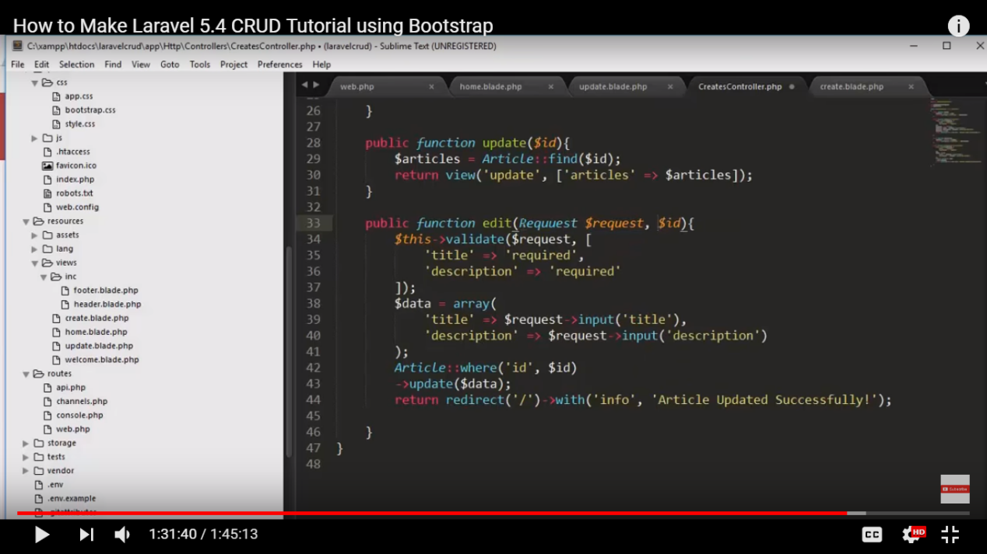

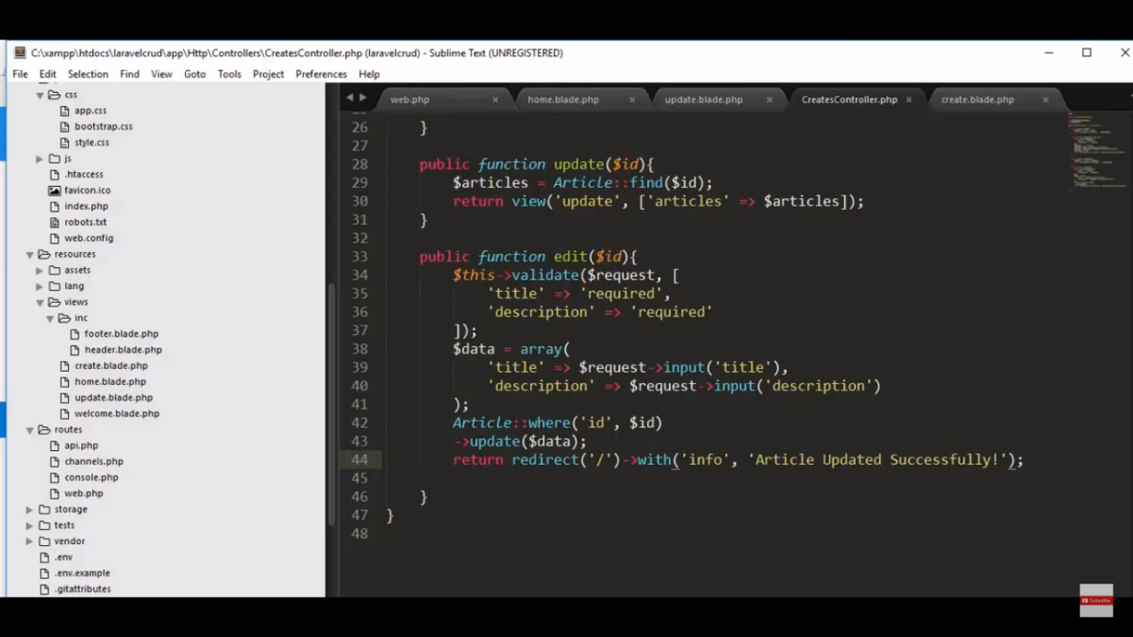

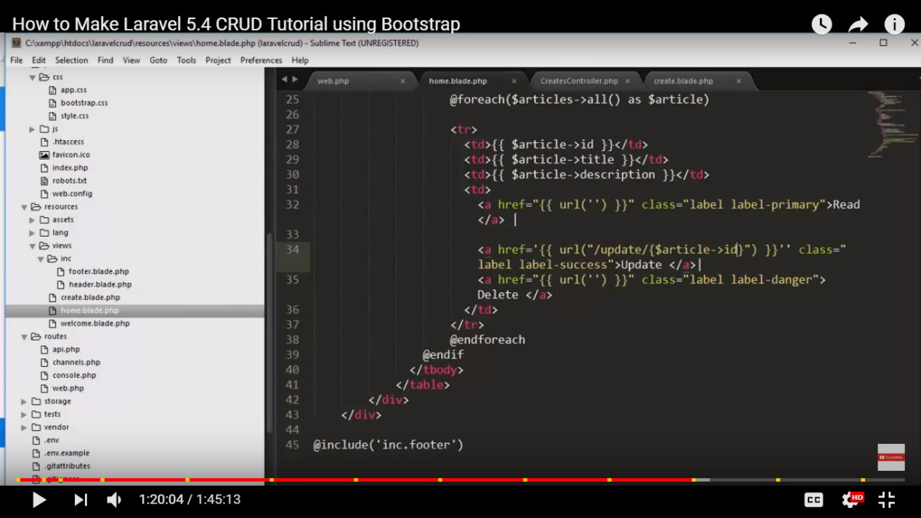

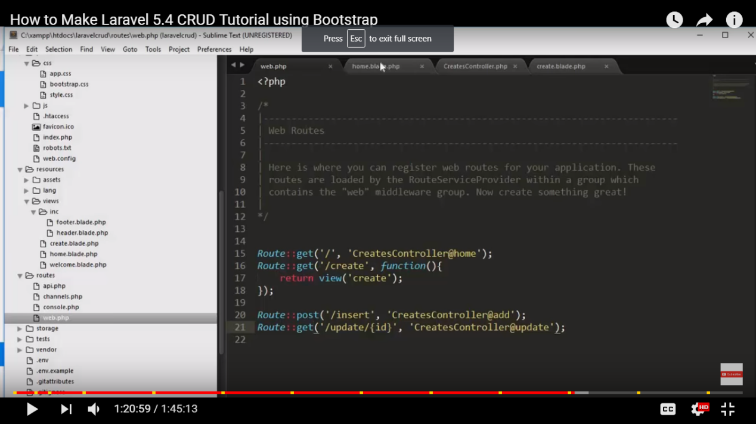

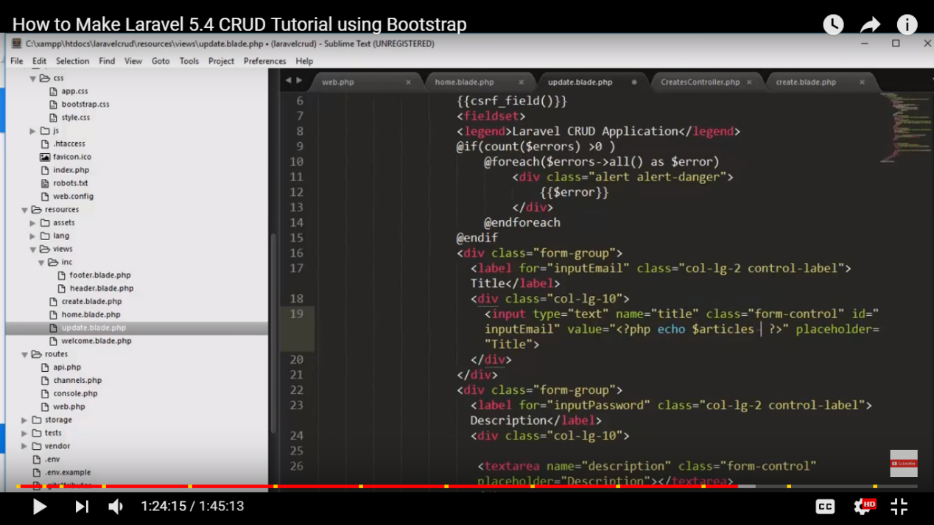

Koi bhi request jaate hai wo pahle hit karta hai router ko.

Routes hai wo url hai. base urls hai.

Route::(‘/’, function())

/ hai root ke liye/

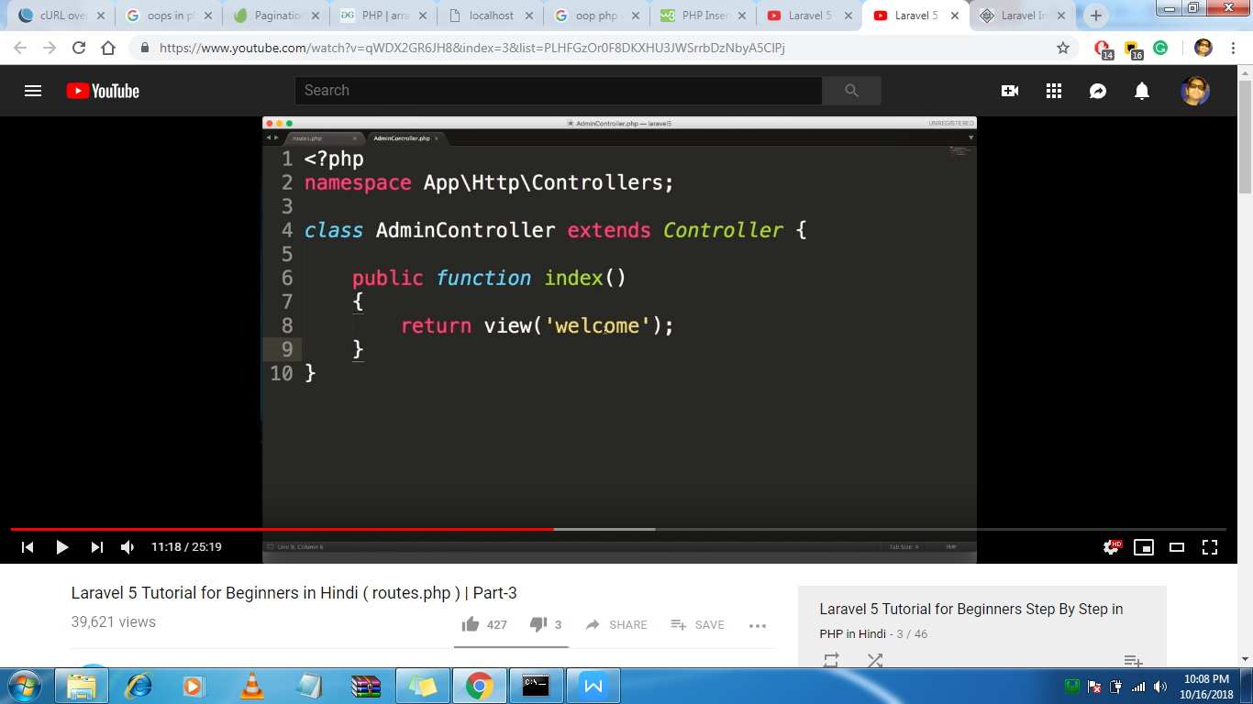

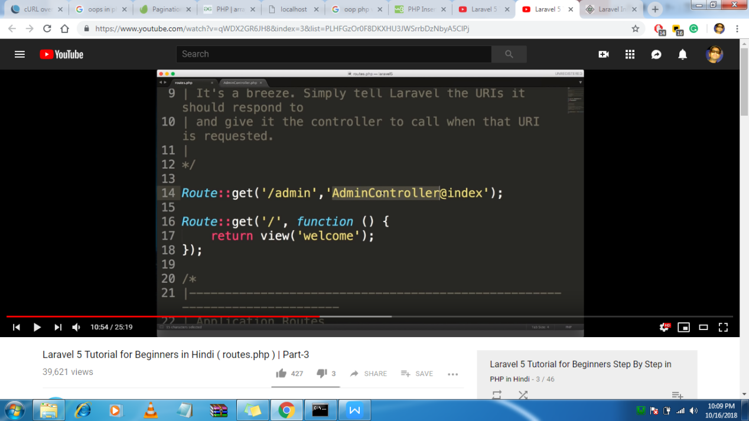

/////

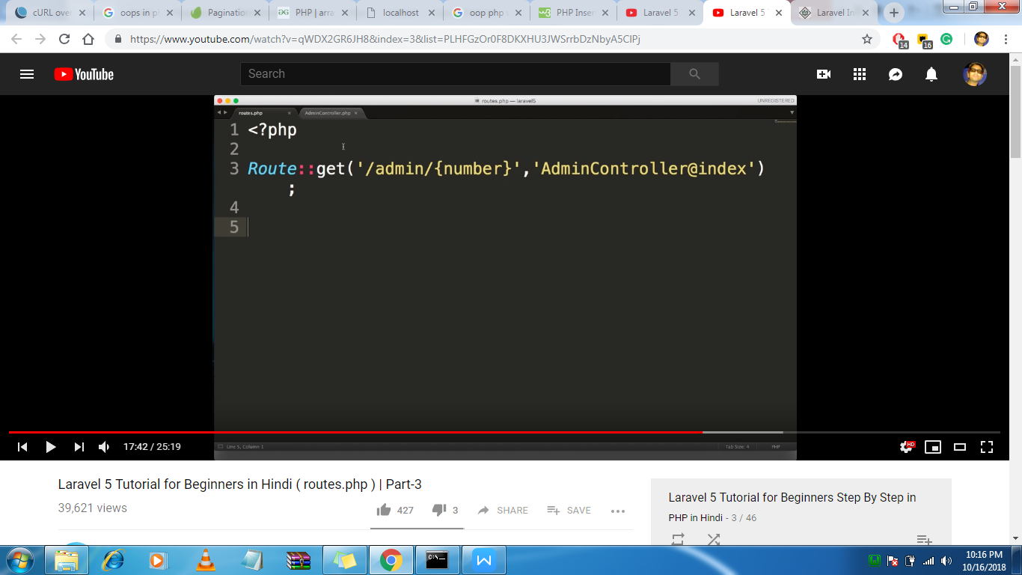

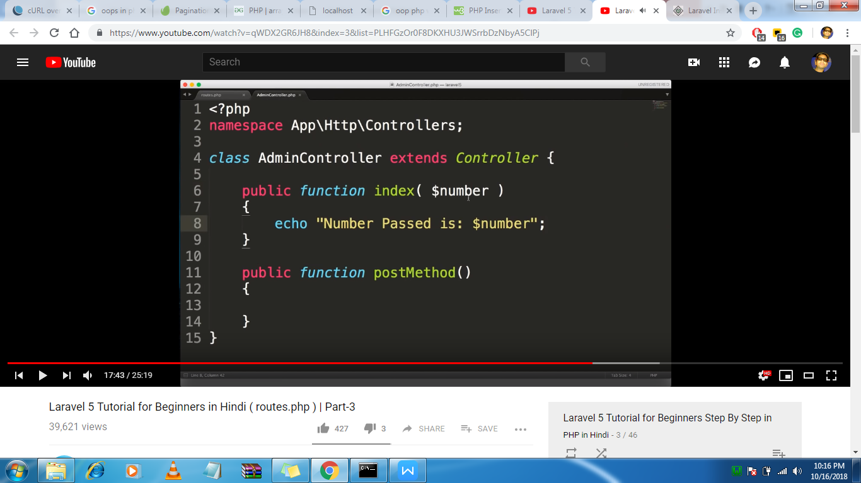

///////

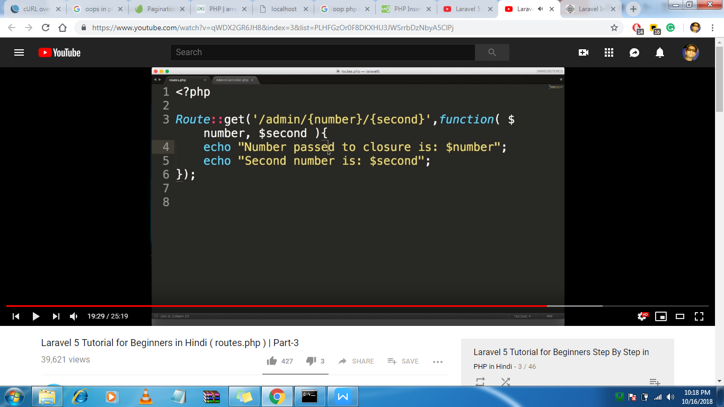

/////

Here ? represent optional

But this will show error

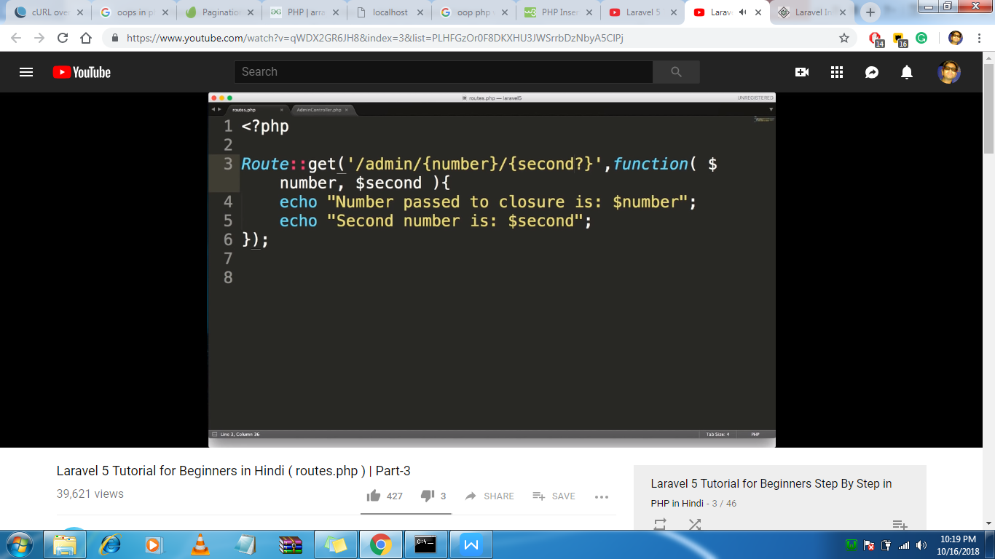

To resolve that we will pass $second = ‘ ’

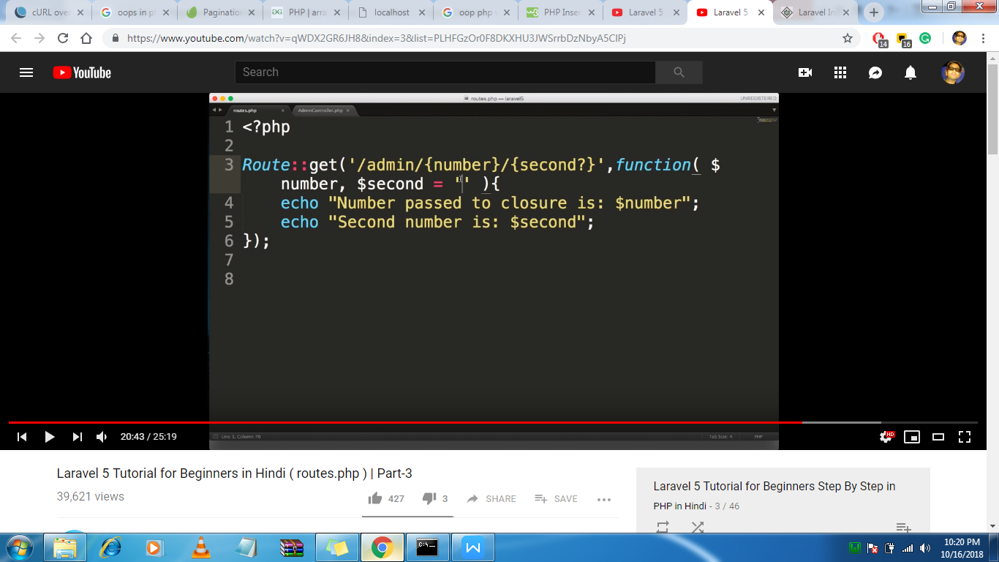

Part 6

Here we are passsing data to the view

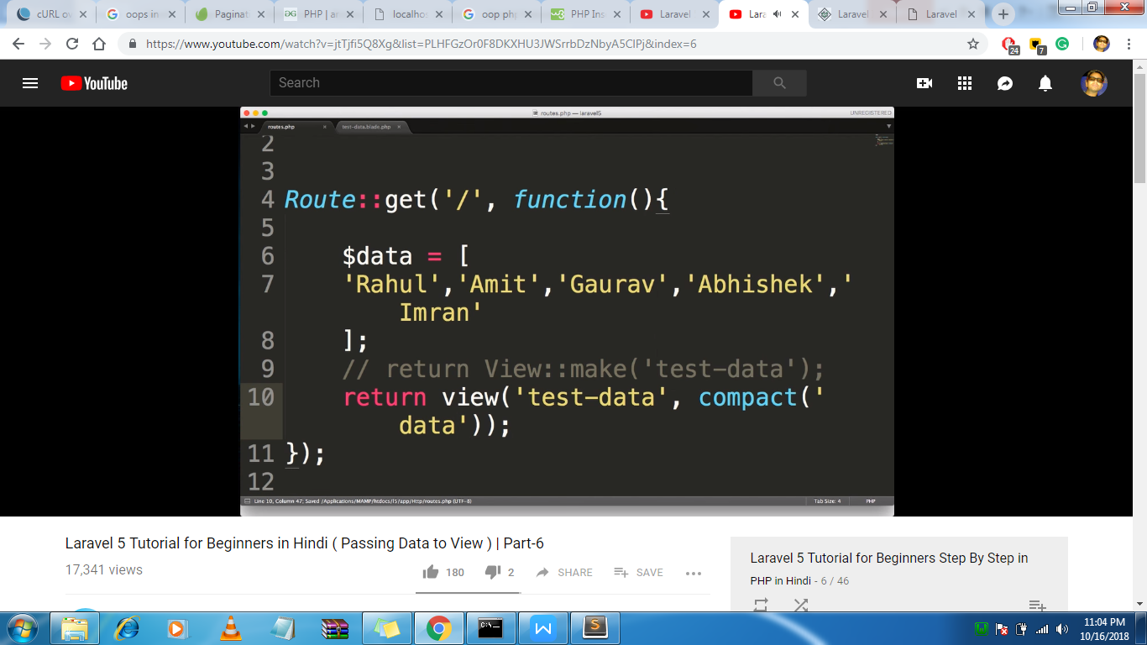

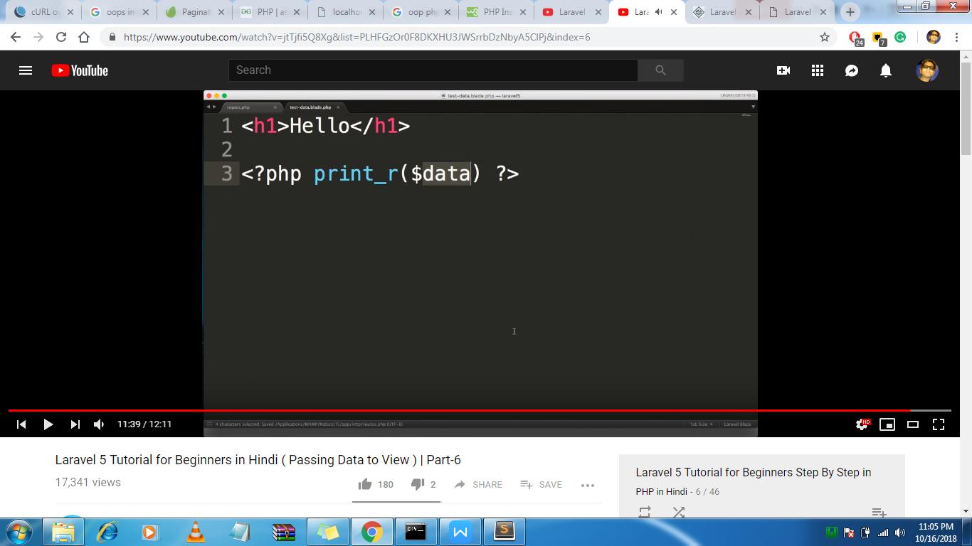

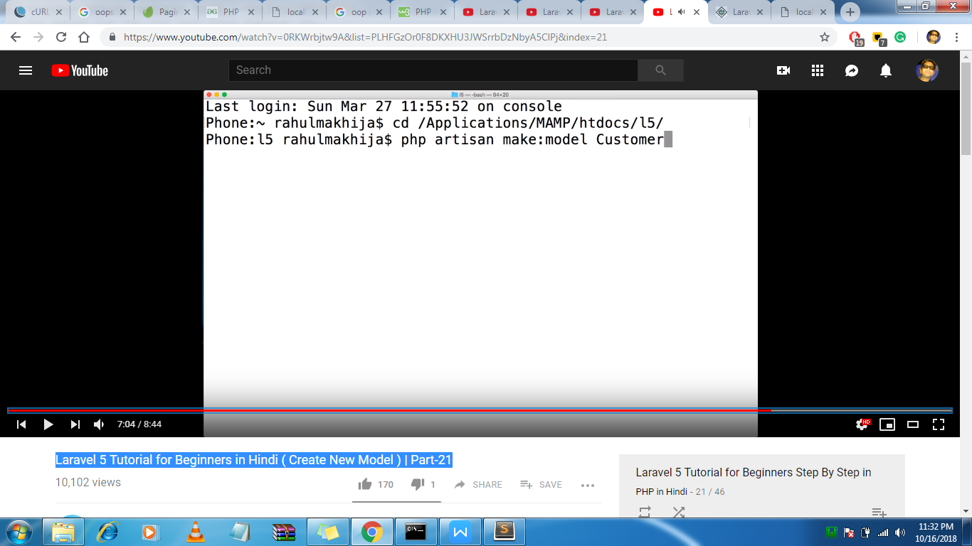

Make model.

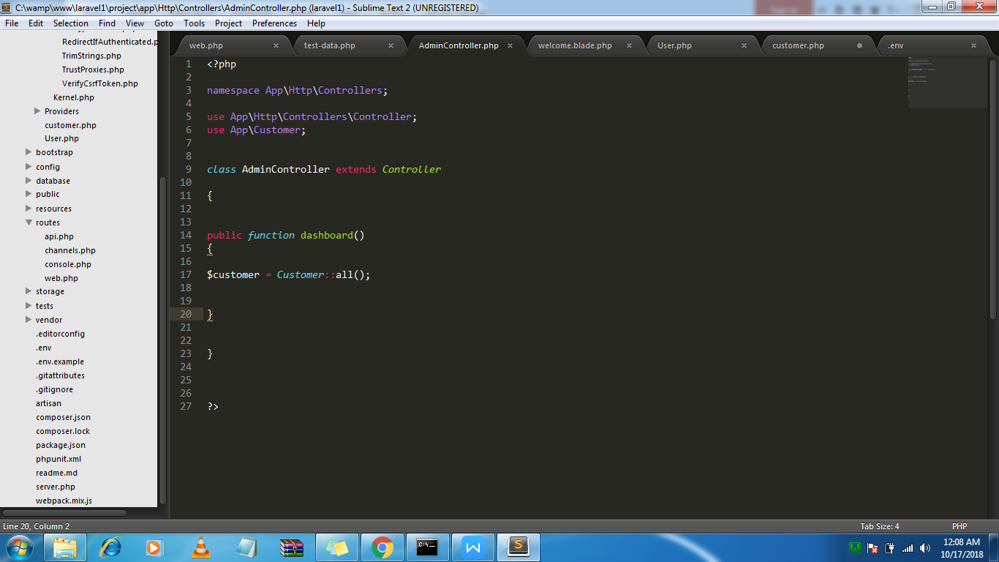

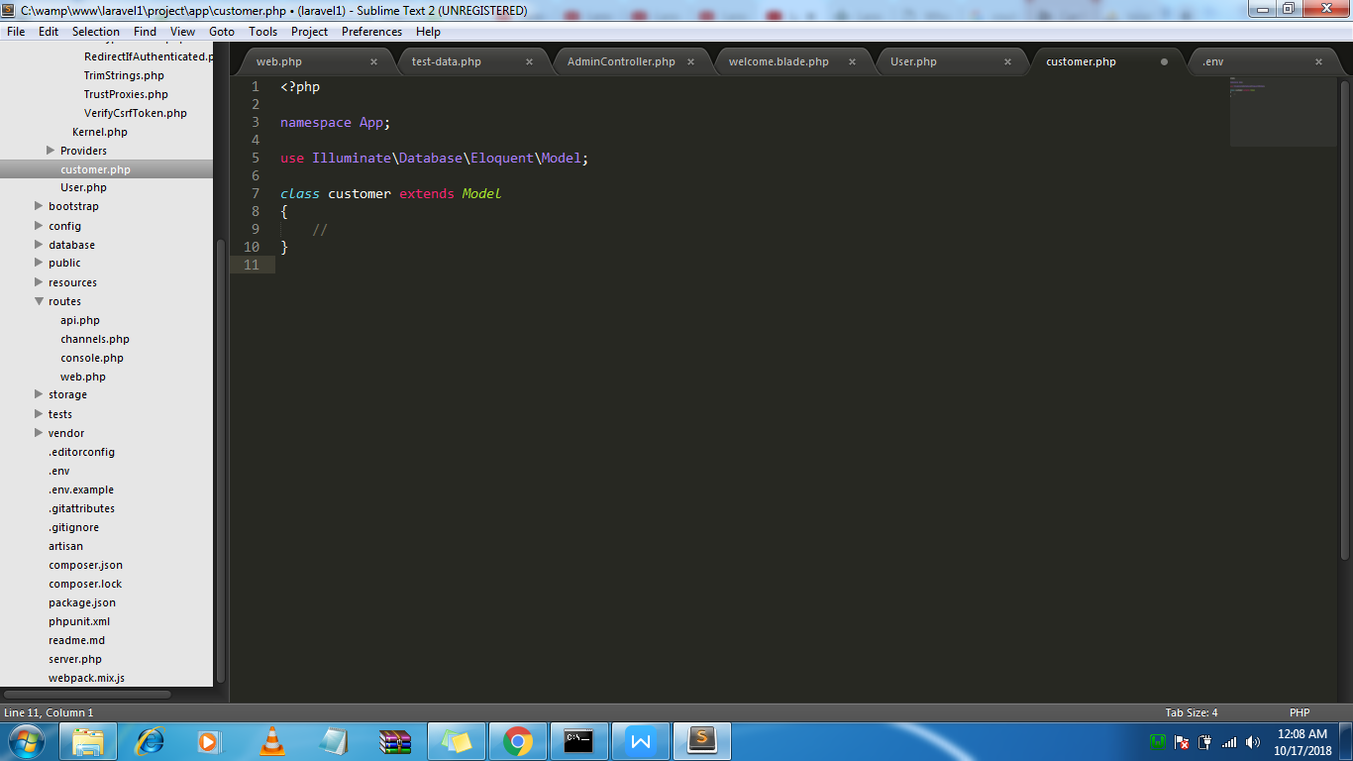

Inside we model we will make $timestamp = false

Insert record in db using model

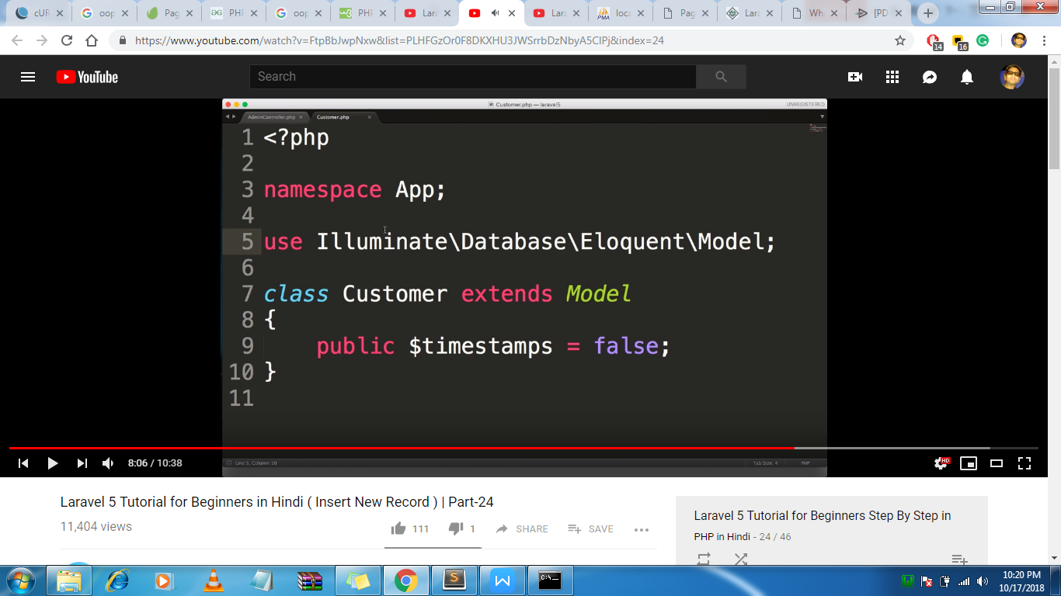

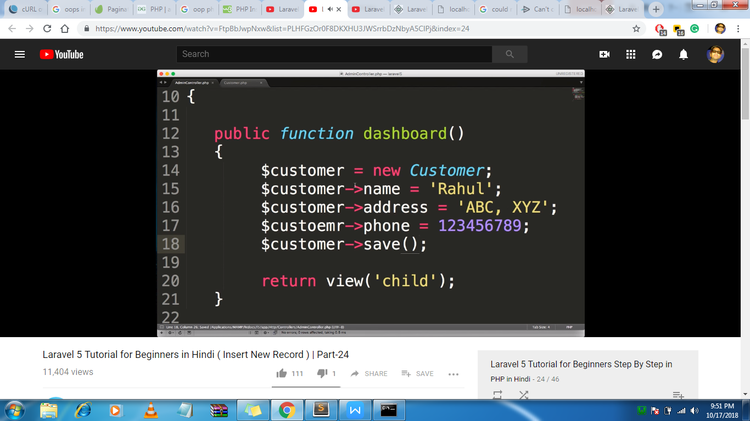

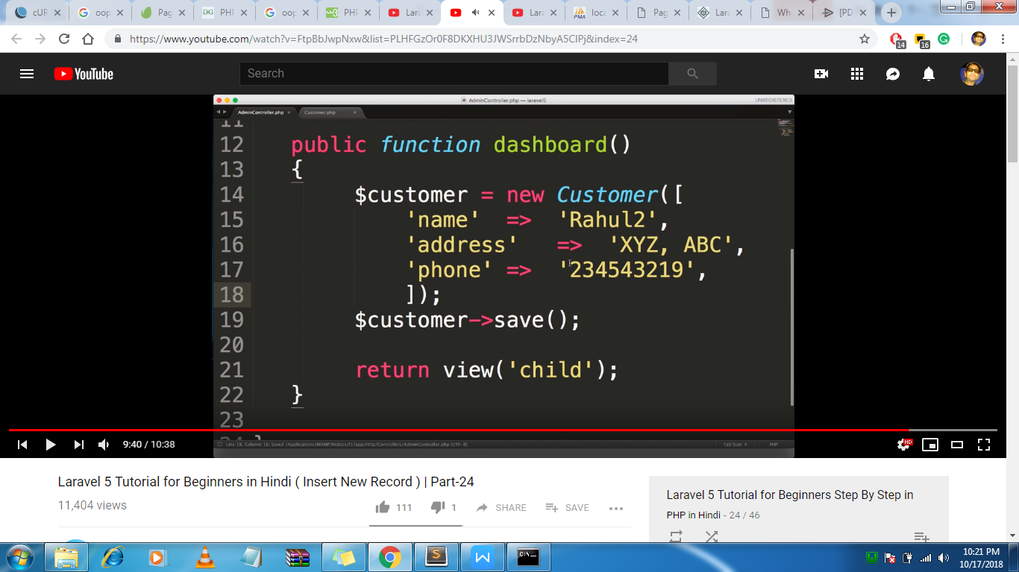

For inserting

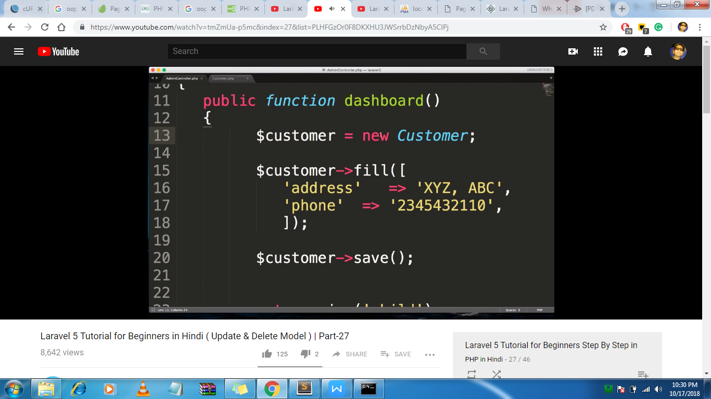

For updation

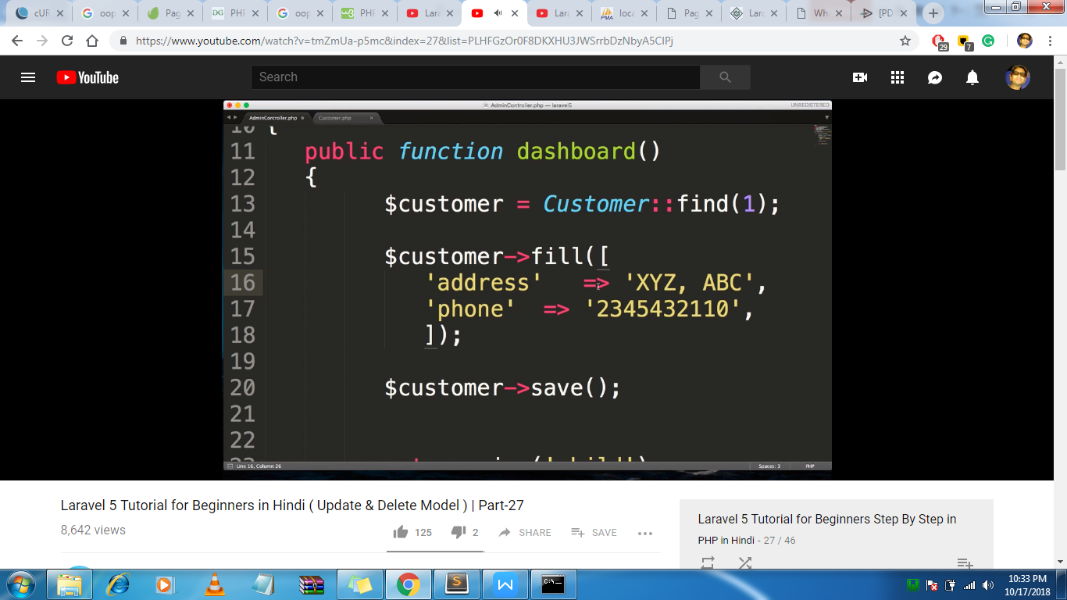

For deletion

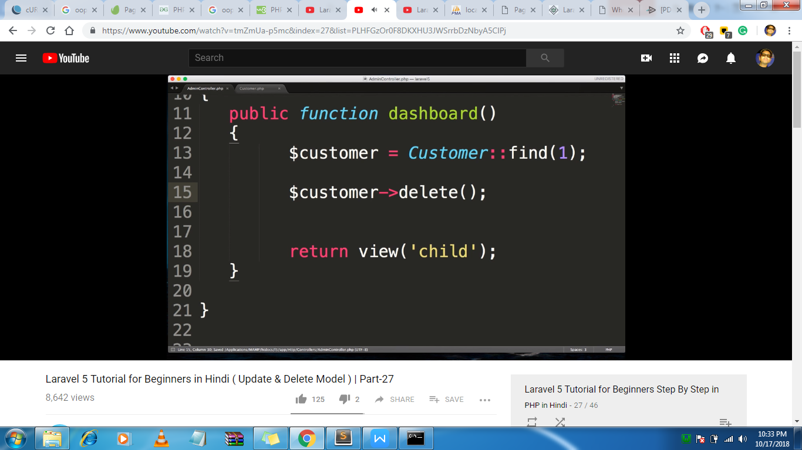

Or destroy

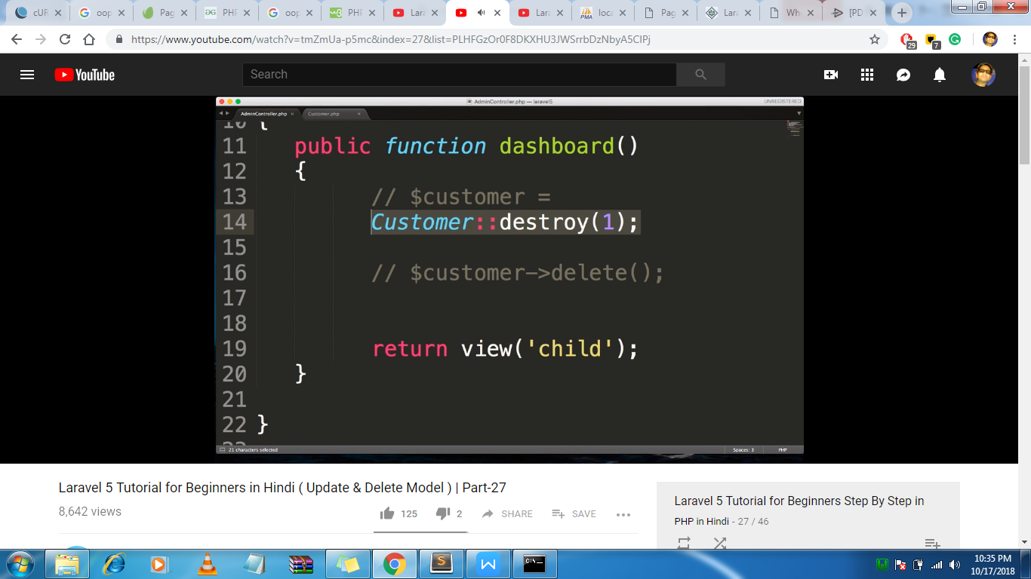

Through form

